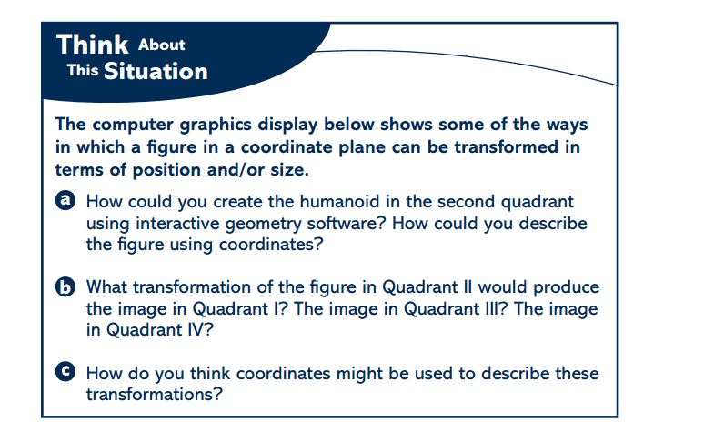
Unit 1- Transformations Name _______________________
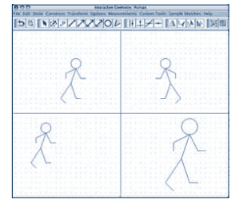

Translations
Problems 2 and 3

2. Horizontal Translation a. In your group, describe the translation as
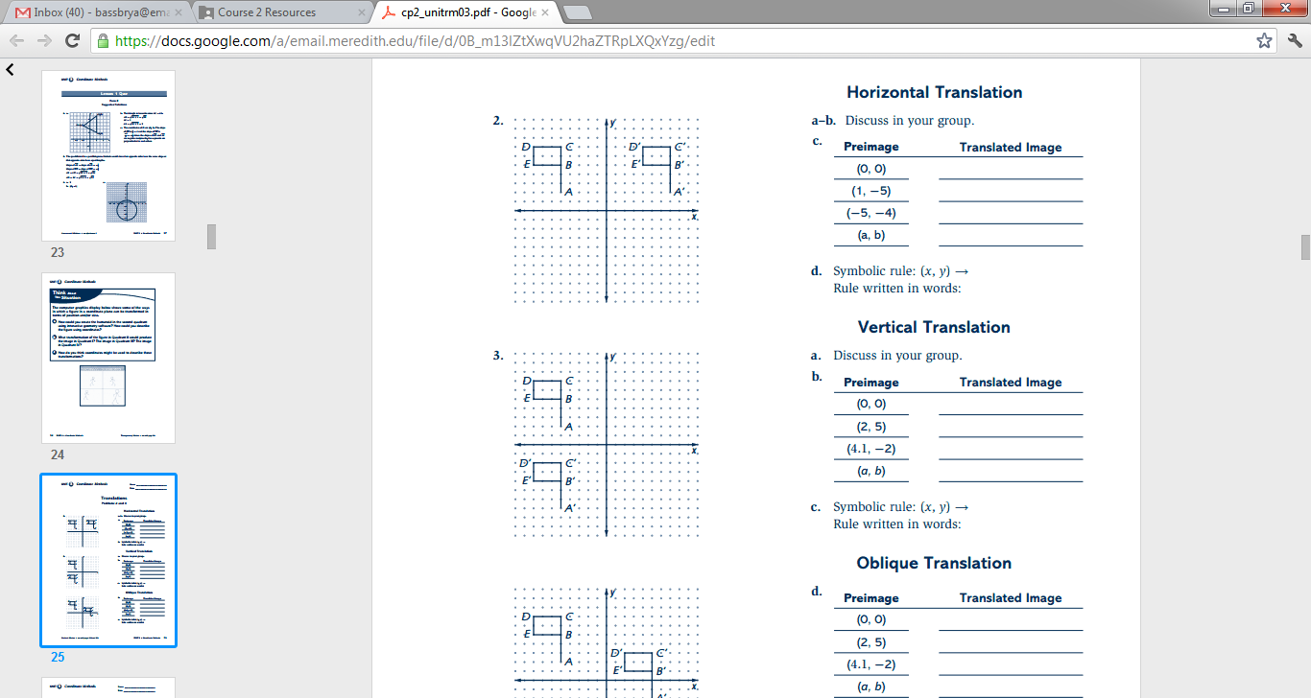
precisely as you can.
b. Discuss in your group how the translated
image of the flag could be produced using
only the translated images of points A, B,C,
D, and E.
c.

d.

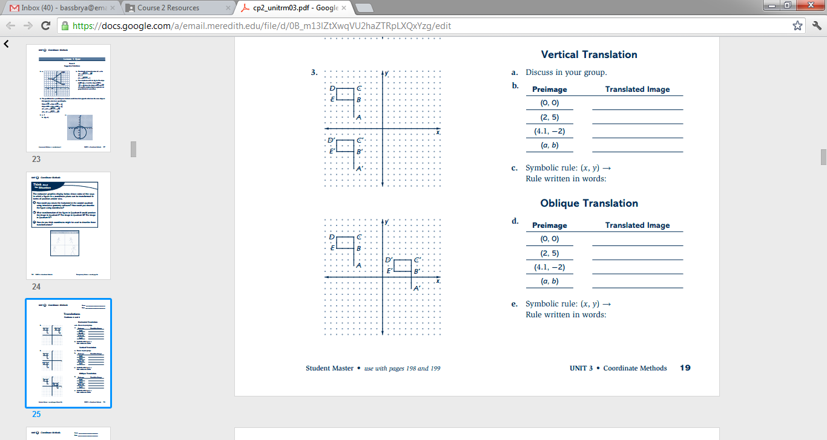
3. Vertical Translation a. In your group, describe the vertical translation as precisely as you can. Also describe the diagonal
(oblique) translation (on the next page).
b.
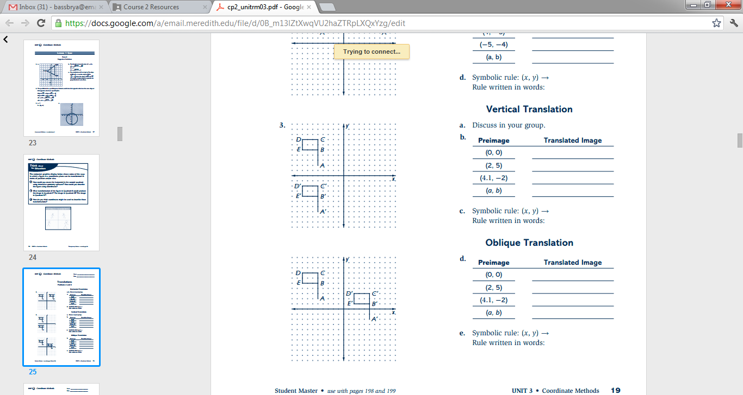

c.

4. Oblique Translation d.

e.

90˚ Counterclockwise Rotation About the Origin
Problem 6

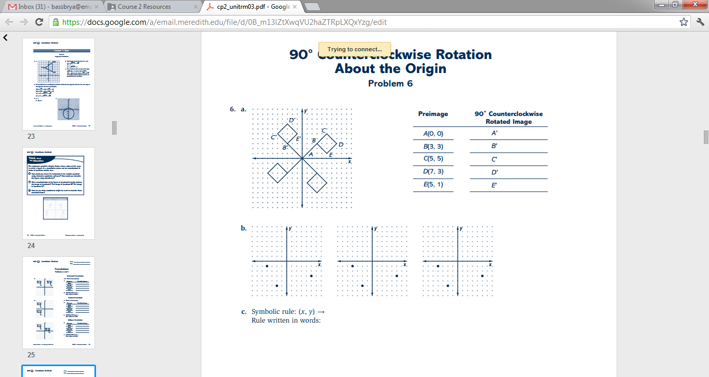
6. Consider flag ABCDE and its image under a 90˚ counterclockwise rotation about the origin.

a. In the table, record the coordinates of the images of the five points on the flag under a 90˚
counterclockwise rotation about the origin. Discuss why the rotated image of the flag could
be produced using only the rotated images of points A, B, C, D, and E.

b. Use any patterns you see between preimage and image points in your completed table to
help plot the images of the points (-2, -5), (-4,-1), (5,-3), under a 90˚ counterclockwise
rotation about the origin on a new coordinate grid.
i. For each preimage point, use dashed segments to connect the preimage to the
origin and the origin to the image.
ii. Connect each preimage segment to its image segment with a “turn” arrow that shows the directed angle of rotation.

First Point: (-2,-5) Second Point: (-4, -1) Third Point: (5,3)

c.

d. According to your rule, what is the image of (0,0)? Why does this make sense?

180˚ and 270˚ Counterclockwise Rotations About the Origin
Problem 7

7. Investigate patterns in the coordinates of preimage and image pairs when points are rotated
180˚ and 270˚ about the origin.

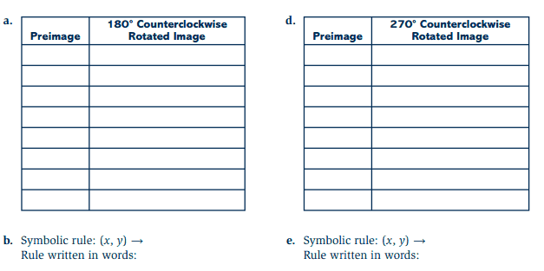

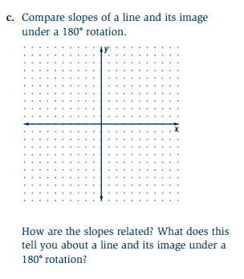

Line Reflections
Problems 8 and 9

8. A flag ABCDE and its reflected image across the y-axis are shown on the screen below.
Investigate patterns in the coordinates of preimage and image pairs when points are reflected
across the y-axis.
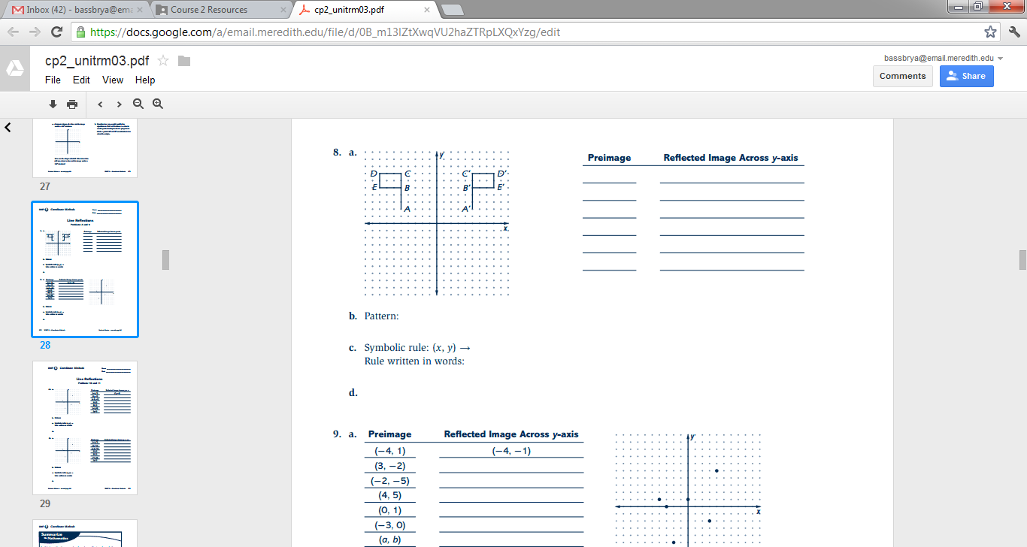
a.

b.

c. On a copy of the diagram, used dashed segments to connect points A to point A’ and point
D to point D’. Use coordinates to verify that the y-axis is the perpendicular bisector of $\overline{AA'}$
and $\overline{DD^{'}}$.

9. The table below shows coordinates of six preimage points and coordinates (a, b) of a general
point. All of the six points are plotted on the coordinate plane below. Plot each of the point’s
reflected image across the x-axis.

a. Record the coordinates of the image points in a table like the one below.
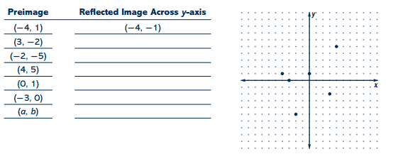

b. What pattern relating coordinates of preimage points to image points do you observe? Use
the pattern to give the coordinates of the image (a, b).

c.

d. How is the x-axis related to the segment determined by any point (a, b) not on the x-axis and
its reflected image? Justify your answer using coordinates.

Line Reflections
Problems 10 and 11

10. Draw the graph of $y=x$. Plot the reflected image of each point in the table below across that
line. Connect each preimage/image pair with a dashed segment.

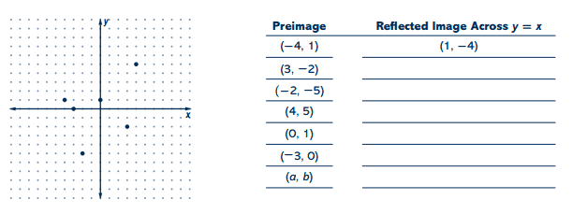
a. Record the coordinates of the image points in a copy of the table below.
b. Describe a pattern relating coordinates of preimage points to image points.

c.

d. How is the line of reflection, $y=x$, related to the segment determined by any point (a, b)
not on the line and its image? Justify your answer.

11. Next, investigate patterns in the coordinates of the preimage and image pairs when points are
reflected across the line $y=-x$.

a. Draw the graph of $y=-x.$ Plot the reflected images of the six preimage points in the table
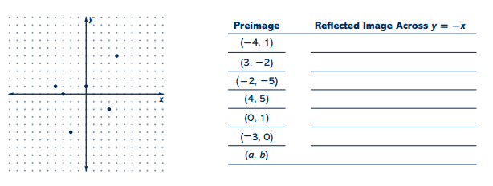
across the line $y=-x.$

b. Describe a pattern relating coordinates of preimage points to coordinates of image points.

c.

d. How is the segment determined by a point and its reflected image related to the line
$y=-x.$

Check Your Understanding

Consider the following triangle with coordinates given.
A(-1, 2), B(4, -3), C(3, 5)
Sketch and label ΔABC and its image under each of the following transformations.

a. i. Reflection across y-axis ii. Translation with horizontal component -3
and vertical component 2
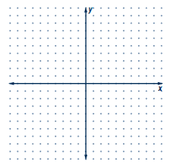

iii. Reflection across the line $y=x$ iv. 180˚ counterclockwise rotation about the
origin

v. 90˚ counterclockwise rotation b. Show ΔABC$≅$ΔA’B’C’ for one of parts i-iv.
about the origin

Size Transformations
Problems 2 and 3

2. A size transformation (or dialation) of magnitude 3 centered at the origin is defined by the
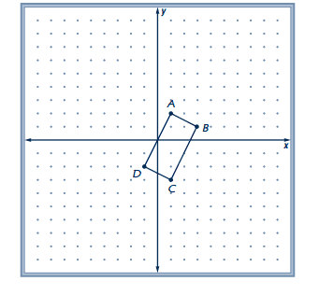
following rule: preimage (x,y) image (3x, 3y)
a. On a copy of the diagram shown here, draw the image
of quadrilateral ABCD under this size transformation.
Label image vertices A’, B’, C’ and D’.

b. Examine your preimage and image shapes. Make a list
of all of the properties of the quadrilateral ABCD that
seem to also be properties of the quadrilateral
A’B’C’D’. Also, describe how the new shapes seem to
differ.

3. Use coordinate representations and formulas for distance and slope to examine more carefully quadrilateral ABCD and its image quadrilateral A’B’C’D’ that you drew in Problem 2.
a. Compare the length of $\overline{AB}$ with the length of $\overline{A'B'}$. Does the same relation hold for other
preimage/image pairs of segments? Explain.

b. How does $\overset{⃡}{AB}$ appear to be related to $\overset{⃡}{AD}$? Does the same relationship hold for their
images? Give evidence to support your claim.

c. How do the perimeters of quadrilateral ABCD and quadrilateral A’B’C’D’ compare?

d. How does $\overset{⃡}{BC}$ appear to be related to $\overset{⃡}{AD}?$ Is this relationship true for their images? Justify
your conclusion.

e. What kind of quadrilateral is ABCD? Is the image quadrilateral A’B’C’D’ the same kind of
quadrilateral? Explain your reasoning.

Size Transformations
Problem 5

5. Next, consider a size transformation with magnitude 0.5and center at the origin.
a. Write a rule for this size transformation.

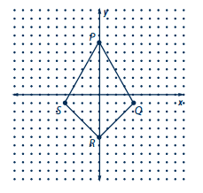
b. On a copy of the diagram shown here, place and
label the image of quadrilateral PQRS
under this size transformation. How do you
think quadrilateral PQRS and its image are
related in terms of shape? In terms of size?

c. Compare segment lengths in the image with corresponding lengths in quadrilateral PQRS.
How does the magnitude 0.5 affect the relation between lengths? Between perimeters?

d. Find the area of the image quadrilateral. Compare it to the area of quadrilateral PQRS. How
does the magnitude 0.5 affect the relation between areas?

Combining Transformations
Problems 5 and 7

5. The process of successively applying two transformations is called composing the
transformations. The transformation that maps the original preimage to the final image is
called the composite transformation. Examine the effects of composing two line reflections
that you have studied.
a. Draw a triangle or a quadrilateral of your choice.

b. Reflect the figure across the x-axis. Then reflect the
image across the line $y=x$.
i. Compare the size, shape, and orientation of the
preimage and image under the composite
transformation.

ii. What kind of transformation does the composition of the two line reflections appear to
be? Be as specific as you can.

iii. Write a symbolic rule $(x,y)→$ (___, __) which describes the composite transformation.

iv. Does the order in which you compose the two line reflections lead to the same final
image?

c. Now reflect the figure across the x-axis and then reflect the image across the y-axis.
i. Compare the size, shape, and orientation of the
preimage and image under the composite
transformation.

ii. What kind of transformation does the composition of the two line reflections appear to
be?

iii. Write a symbolic rule $(x,y)→$ (__, __) which describes the composite transformation.

d. What is the effect of reflecting across the same line twice?

7. Make a conjecture about the effects on shapes of composing a size transformation with center
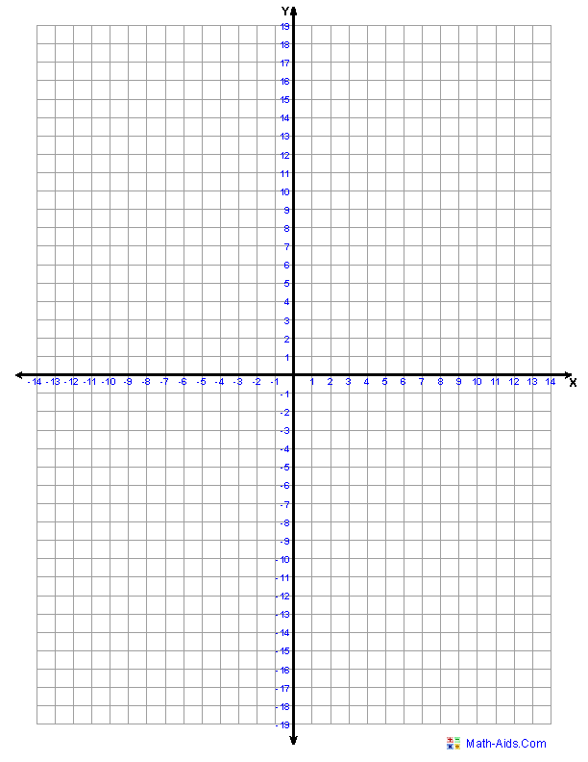
at the origin and a translation.
a. Test your conjecture by drawing ΔABC
with vertex coordinates A(2,8), B(14,4),
and C(10,18). Then find the image of
ΔABC under the composite transformation:
size transformation of magnitude $\frac{1}{2}$ with
center at the origin followed by a
translation with components 3 and -10.
What are the coordinates of the vertices of
the image of ΔABC under this composite
transformation?

b. How are segment lengths affected by composing a size transformation with a translation?

c. How are angle measures affected by composing a size transformation with a translation?

9. Figures that are related by a size transformation, or by a composite of a size transformation
with a rigid transformation, are called similar. The composite transformation is called a
similarity transformation. The magnitude of the similarity transformation is the scale factor.
Consider the similarity transformation that is the composition of these two transformations in
the order given:
Transformation I $(x,y)→(\frac{2}{ 3}x,\frac{2}{3}y)$
Transformation II $(x,y)→(x,-y)$
a. Describe each of the transformations as completely as possible.

b. Consider ΔPQR with vertex coordinates P(6,12), Q(18,0), and R(12,-6). What is the image
of ΔPQR under the similarity transformation?

c. Write a rule $(x,y)→$ (__, __) which describes the similarity transformation. Compare your
rule to that of others and resolve any differences.

d. What is the scale factor of the similarity transformation?

e. How would your answers to Parts b-d change if Transformation II was applied first to
ΔPQR?

